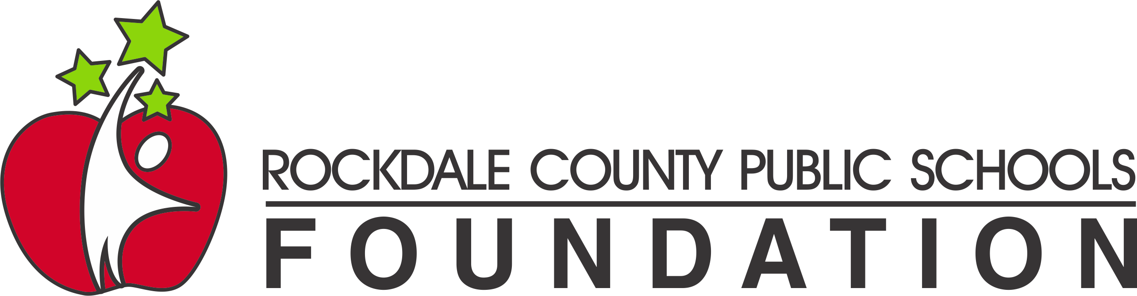
Mini-Grants
EMAIL SUBMISSIONS ONLY

Purpose: To provide funding to implement innovative and impactful projects and offer unique opportunities to improve student achievement, staff satisfaction and personalized learning experiences.
The RCPS Foundation grants are offered to support teachers and staff in Rockdale County Public Schools to expand educational opportunities for students.

Who May Apply: All RCPS staff members, departments, grade levels, or cross-disciplinary teams may apply. (This includes all departments, e.g., Media Center, Athletics, Music, Professional Learning, Technology, Drama, Food Services, Counselors, Directors, Transportation, B&G, Programs/Initiatives, Student Support, Learning Support, School Safety, etc.) You may submit no more than two proposals, whether as an individual or part of a team.

Grant Amounts: Grants are available FOR UP TO $1,000.00. The grant money must be expended by May 2026. Please note that once a proposal is selected for an award, the amount requested may be reduced to accommodate funding limits or ineligible items.

Guidelines: When submitted, applications must include a statement within the email that the school principal or an administrator is aware of and approves of all activities described in the grant proposal. More information can be found at RCPSFoundation.com

All activities must be consistent with existing school system policies, and initiatives should align with current learning theory and research standards. Innovation and creativity are appreciated.

* Page limit for all content is four pages with attachments, double-spaced
using Arial or Times New Roman font, 12-point size, with 1-inch margins.
The page limit does not include the cover sheet. *

FOR JUDGING PURPOSES, DO NOT INCLUDE THE SCHOOL'S NAME OR OTHER IDENTIFYING INFORMATION IN THE TITLE OR BODY OF THE GRANT APPLICATION.

Submit applications via EMAIL in pdf format to RCPS Foundation
no later than Monday, April 14, 2025, 11:59 p.m.

Failure to follow all directions will result in point deductions or disqualification.

Projects that include technology – hardware or software, including robots, web-based platforms, and anything that requires an app – must complete a Technology Acquisition Request. This can be found here - Technology/Digital Resource Acquisition form. Please note that this form is due BEFORE SPRING BREAK to be approved. This is a district deadline, not a Foundation deadline. Please contact your DLS with questions about this.

Please contact the RCPS Foundation Administrator with any questions – RCPSFoundation@rockdale.k12.ga.us - do not contact the Foundation directly or submit applications on the website. Recipients must account for all funds awarded. In addition, each grant recipient must report on the project's implementation and outcome in a final report due in May 2026.

2025-2026 Grant Application

Project Name:_____________________________________________________

Applicant Name:___________________________________________________

School/Department:________________________________________________

How many students and/or staff will be impacted by your project?__________

Total Funding Requested: ______________________

I have reviewed this RCPS Foundation Grant Application and approve its content, scope and budget.

________________________________________ ____________________
Principal/Director/Supervisor Signature Date

Applicant - initial one:

_____________ This project does not propose a new curriculum or program.

_____________ This application proposes a new curriculum or program that has been reviewed and approved by __________________________ in the RCPS Curriculum & Instruction Department.
(name)

School Year 2025-2026 Grant Application

DIRECTIONS
Please use this document to complete the Grant Application. Place your responses under the appropriate question. This document should not exceed 4 pages, not including the cover sheet. Margins should remain 1” using Times New Roman or Calibri, 12pt.

PROJECT OVERVIEW
- Project Name:
Brief description (25 words or less):

- Why is this project needed? Include data or information that demonstrates and/or supports the need.

PROJECT DETAILS
- Describe how the project will be implemented and how it addresses the need you described in Question 2. What activities/materials/technology will be used to accomplish your project? (Be sure the items requested in your budget are mentioned in this project description.)

- Targeted participants (# of students, grade level, subject area)

  - Describe your participants (e.g. grade, subject, etc.)_____________

  - How many will be impacted by your project? (list an actual number here) ___________
PROJECT EVALUATION
- How will you evaluate the success of your project and improvement in the need you described in Question 2?

BUDGET
- What are the costs associated with the project? Be as specific as possible (item, vendor, quantity, price.) Ensure all items requested are mentioned in your Project Description (Question 3). If your budget is over the $1,000 grant limit, where will you get the balance needed to implement your project?

  - Materials and Supplies

  - Technology (hardware and/or software)

  - Memberships/Registration Fees/Entry Costs

  - Travel

  - Honorarium

  - Food/Awards/T-shirts

  - Other

Total $_____________

- Projects that include technology or digital resources – hardware or software, including robots, web-based platforms, and anything that requires an app – must complete a Technology Acquisition Request. This can be found here - Technology/Digital Resource Acquisition form. Please note that this form is due BEFORE SPRING BREAK to be approved. This is a district deadline, not a Foundation deadline.

Applicant - INITIAL ONE:

______ My project does not require a Tech Aquisition Form.

______ My project contains technology or digital resources and I have completed a Tech Acquisition Form.

https://studentsrockdalek12ga.sharepoint.com/sites/technologyacquisition

